Final Project Report

Job Application Tracker



Project Supervisor
Dr. Nida Anwar

Submitted By

Zara Ahmed BC220409531

Software Projects & Research Section,
Department of Computer Sciences,
Virtual University of Pakistan


CERTIFICATE

This is to certify that Zara Ahmed (BC220409531) has worked on and completed their Software Project at Software & Research Projects Section, Department of Computer Sciences, Virtual University of Pakistan in partial fulfillment of the requirement for the degree of BS in Computer Sciences under my guidance and supervision.

In our opinion, it is satisfactory and up to the mark and therefore fulfills the requirements of BS in Computer Sciences.

Supervisor / Internal Examiner

Dr. Nida Anwar
Supervisor,
Software Projects & Research Section,
Department of Computer Sciences
Virtual University of Pakistan

___________________
(Signature)

External Examiner/Subject Specialist
Dr. Nida Anwar

___________________
(Signature)

Accepted By:

_____________
(For office use)

EXORDIUM

In the name of Allah, the Compassionate, the Merciful.

Praise be to Allah, Lord of Creation,
The Compassionate, the Merciful,
King of Judgment-day!

You alone we worship, and to You alone we pray for help,
Guide us to the straight path

The path of those who You have favored,

Not of those who have incurred Your wrath,
Nor of those who have gone astray.

DEDICATION

I would like to dedicate this work those people who played an important role in my success and whose presence contributed to achieve this milestone so far i.e.

My Parents and My Teachers.

In addition, I would also like to dedicate it to all those who have helped us and contributed in our success.

ACKNOWLEDGEMENT

Words are bound and knowledge is limited to praise Almighty Allah, the lord of the world, the Beneficent, Merciful and the Gracious. Who is the entire source of all knowledge and wisdom endowed to mankind and who presented me in a Muslim community, whose blessing are the cherish fruits of my thoughts and modest effort in the form of this manuscript. The blessings of Allah give to me the ability to contribute a drop of material to the existing ocean of scientific knowledge.

Trampling lips and wet eyes for Hazrat Muhammad (S.A.W) from the deepest core of my heart, which is forever model of guidance and knowledge for humanity. The very special entity the Allah has brought into our lives, whose saying “Learn from cradle to grave” awakened the strong desire in my life to under taken this course of study and write up of this manuscript
.
With the humble profound and deep sense of derision I wish to record appreciation and sincere thanks to my all Teachers of Virtual University, Lahore for their sincere, kind guidance and cooperation during my studies.

Now I wish to acknowledge with deep sense of gratitude for sincere and able guidance, keen interest, valuable suggestions and advice received from learned Supervisor
Dr. Nida Anwar

I expressed my deepest gratitude to my dear Parents. I am really appreciating the help of all. They always wish to see me glittering high at the skies of success. No words can explain my obligation to our parents whose encouragement will a tower of light for us. Their advices will guide me in every field of my life. May they live long.

PREFACE

To vision anything that you desire to dream that’s the attractiveness of human mind. To do something you would like to achieve that is the power of human will. To trust yourself to test your limits, that is courage to succeed. I am thankful to my worthy teacher who has imparted us with a lot of valuable directions and knowledge.

This is complete documentation of my project “Job Application Tracker” This is my final project of BS Computer Science.

TABLE OF CONTENTS

1. CHAPTER 1 - Gathering & Analyzing Info 9
1.1 Introduction 9
1.2 Scope of Project: 9
1.3 Functional and non Functional Requirements: 10
1.4 Use Case Diagram: 12
1.5 Usage Scenarios: 13
2. CHAPTER 2 - Planning the Project 19
2.1 Introduction of the Planning Phase: 19
2.2 Methodology: 20
2.3 Available Methodology: 20
2.4 Chosen Methodology: 22
2.5 Reasons for choosing the Methodology: 22
2.6 Work Plan: 23
2.7 Project Schedule 23
3. CHAPTER 3 - Designing the Project 26
3.1 Introduction: 26
3.2 Scope: 26
3.3 Entity Relationship Diagram (ERD): 27
3.4 Sequence Diagrams 29
3.5 Class Diagram 33
3.6 Database Design 34
3.7 Interface Design 36
4. CHAPTER 4 - Development 45
4.1 Architecture Design Diagram 45
4.2 Test Cases 46
4.3 Development Tools & Technologies 51

CHAPTER 1
Gathering & Analyzing Info

CHAPTER 1 - Gathering & Analyzing Info

1.1 Introduction

The Job Application Tracker app is designed to enable users to manage job applications efficiently by tracking application progress, storing resumes and cover letters, setting reminders for interviews and deadlines, and monitoring overall progress through an interactive dashboard.

1.2 Scope of Project:

The Job Tracking Application is designed to simplify and streamline the job application process. It provides a centralized platform accessible across mobile phones, laptops, and desktop computers. Users can record unlimited job applications with essential details such as company name, address, contact information, and email,

Each application can be tracked for status like applied, response received, interview/test date, rejected, or offer accepted. Users can upload resumes, cover letters, and appointment letters, keeping all documents organized in one place. The application allows email or in-app reminders for deadlines, interviews, and tests, while a visual dashboard presents job statuses in graphs or tables for easy monitoring.

This solution makes it easier to keep track of job applications, saving users time and reducing stress, so they can spend more energy preparing for interviews and tests instead of handling tasks manually

In-Scope Features / Deliverables:
- Multi-platform accessibility (mobile, laptop, desktop)
- Recording and managing unlimited job applications, including company details (name, address, contact info, contact person and email)
- Tracking application status (applied, response received, interview/test date, rejected, offer accepted)
- Uploading resumes, cover letters, and appointment letters
- Setting reminders via email or notifications for application deadlines, interviews, and tests
- Dashboard with graphs or tables to provide a visual summary of all job applications
Users / Stakeholders:
- Students, freshers, and experienced job seekers actively applying for jobs
Benefits / Expected Outcomes:
- Saves time by eliminating manual tracking and management of applications
- Help users stay organized and avoid missing deadlines
- Allows users to focus on preparation for interviews and tests rather than administrative tasks
- Provides a centralized, easy-to-use platform for job application management

1.3 Functional and non Functional Requirements:

Functional Requirements:

- User Management:
  - FR1.1: Users can register an account using email and password.
  - FR1.2: Users can log in and log out securely.
  - FR1.3: Users can manage their profile including personal details and career preferences.
- Job Application Management:
  - FR2.1: Users can add a new job application with details such as company name, position, job link, date applied and contact information.
  - FR2.2: Users can update or delete existing job applications.
  - FR2.3: Users can set the status of each application (Applied, Screening, Interview, Offer, Rejected).
  - FR2.4: Users can attach and manage related documents like resumes, cover letters, and job descriptions.
- Dashboard & Reports:
  - FR3.1: Users can view a summary of active, pending, and completed applications.
  - FR3.2: Users can visual representations such as: Pie charts, Bar charts, Tables
  - FR3.3: User can filter applications by date, status, or company.
- Reminders & Notifications:
  - FR4.1: Users can set reminders for interviews date and test date.
  - FR4.2: Users receive notifications via email or in-app/mobile alerts.
- Document Management:
  - FR5.1: Users can securely upload, store, and retrieve files.
  - FR5.2: Users can associate multiple versions of resumes or cover letters with specific applications.
- Security & Authentication:
  - FR6.1: Authentication and authorization are handled via JWT (JSON Web Tokens).
  - FR6.2: Data access is restricted to the logged-in user.

Non-functional Requirements:

- Performance:
  - NFR1.1: The system should load dashboards and reports within 3 seconds.
  - NFR1.2: File uploads/downloads should handle at least 10 MB per file without significant delay.
- Usability:
  - NFR2.1: The user interface should be intuitive and easy to navigate.
  - NFR2.2: Both web and mobile interfaces should be responsive and user-friendly.
- Reliability:
  - NFR3.1: The system should be available 99% of the time (excluding maintenance).
  - NFR3.2: User data must be stored reliably with backup mechanisms in place.
- Scalability:
  - NFR5.1: The application should support a growing number of users without significant performance degradation.
  - NFR5.2: Database should be capable of handling an increasing number of job applications per user.
- Maintainability:
  - NFR6.1: Code should be modular and follow best practices to simplify updates and maintenance.
- Portability:
  - NFR7.1: The application should run on major web browsers (Chrome, Firefox, Edge, Safari).
  - NFR7.2: The app should be responsive for both Android and iOS devices.

1.4 Use Case Diagram:

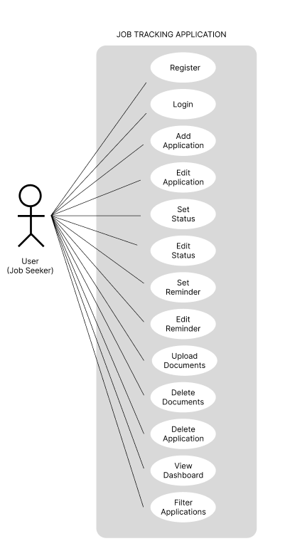

1.5 Usage Scenarios:

1. User Registration & Login

Scenario ID | US-01
Scenario Name | User Registration
Primary Actor | New User
Preconditions | User is not registered in the system
Trigger | User selects “Sign Up”
Main Flow | 1. User enters required details (email, password, phone).  2. System validates details.  3. System creates account.  4. User receives confirmation.
Alternate Flow | A1: Email already exists → system shows error.  A2: Invalid details → system asks for correction.
Postconditions | User account is created successfully

Scenario ID | US-02
Scenario Name | User Login
Primary Actor | Registered User
Preconditions | User has a valid account
Trigger | User selects “Login”
Main Flow | 1. User enters credentials.  2. System verifies credentials.  3. User is logged in successfully.
Alternate Flow | A1: Invalid credentials → system denies access.
Postconditions | User is authenticated and redirected to dashboard

2. Adding and Managing Job Applications

Scenario ID | US-03
Scenario Name | Add New Job Application
Primary Actor | User
Preconditions | User is logged in
Trigger | User clicks “Add Application”
Main Flow | 1. User enters job details.  2. System validates required fields.  3. System saves application.  4. Application appears in list.
Alternate Flow | A1: Required fields missing → shows warning.
Postconditions | New job application is stored in system

Scenario ID | US-04
Scenario Name | Edit Job Application
Primary Actor | User
Preconditions | Application exists
Trigger | User selects “Edit”
Main Flow | 1. User modifies details.  2. System validates and updates data.
Postconditions | Application details are updated

Scenario ID | US-05
Scenario Name | Delete Job Application
Primary Actor | User
Preconditions | Application exists
Trigger | User selects “Delete”
Main Flow | 1. System shows confirmation.  2. User confirms deletion.  3. System deletes application.
Alternate Flow | A1: User cancels deletion.
Postconditions | Application is removed from list

3. Tracking Application Status

Scenario ID | US-06
Scenario Name | Update Application Status
Primary Actor | User
Preconditions | Job application exists
Trigger | User selects a status (e.g., Applied, Interview Scheduled)
Main Flow | 1. User selects new status.  2. System updates status and timestamp.
Postconditions | Status is updated and visible on dashboard

4. Document Upload & Management

Scenario ID | US-07
Scenario Name | Upload Document
Primary Actor | User
Preconditions | Application exists
Trigger | User selects “Upload Document”
Main Flow | 1. User uploads file (PDF/Doc).  2. System validates file size/format.  3. System stores file.
Alternate Flow | A1: Invalid file format → error message.
Postconditions | Document is linked with the application

Scenario ID | US-08
Scenario Name | View or Download Document
Primary Actor | User
Preconditions | Document is uploaded
Trigger | User clicks “View/Download”
Main Flow | 1. System retrieves file.  2. User views/downloads the document.
Postconditions | Document is accessed successfully

5. Notifications & Reminders

Scenario ID | US-09
Scenario Name | Set Reminder for Interview/Test
Primary Actor | User
Preconditions | Interview/test date exists for application
Trigger | User selects “Set Reminder”
Main Flow | 1. User selects reminder time.  2. System schedules notification.
Postconditions | Reminder is stored and will trigger at appropriate time

Scenario ID | US-10
Scenario Name | Receive Notification
Primary Actor | User
Preconditions | Reminder is set
Trigger | Reminder time arrives
Main Flow | 1. System sends email or in-app alert.  2. User views notification.
Postconditions | User is reminded on time

6. Dashboard & Visualization

Scenario ID | US-11
Scenario Name | View Dashboard
Primary Actor | User
Preconditions | User has job applications saved
Trigger | User navigates to dashboard
Main Flow | 1. System loads statistics.  2. Displays charts and tables.
Postconditions | User views overall progress and insights

CHAPTER 2
Planning the Project

CHAPTER 2 - Planning the Project

2.1 Introduction of the Planning Phase:

The project planning are full, actionable descriptions of how the solution will actually be built during the developing, stabilizing, and deploying phases of the project. The project planning phase is the second phase in the project life cycle. The project planning phase follows the project beginning phase. Project planning phase identifies scope, tasks, schedules, feature and recruitment needs. Project Planning is important for a project's success. Project Planning help team members to know their tasks and expectations from them and also in this phase the team works from beginning to end the design process to prepare work plans, calculate a budget and determine what resources are needed and define schedules for the different deliverables and delivery dates. The effort spent in planning can save immeasurable hours of confusion and modify in the subsequent phases invest in building complete project plans will enable you to accurately project required time and costs, build realistic schedules, and develop a complete representation of the sequence of tasks that must occur to complete the project. In the Planning Phase, the team defines the explanation in detail what to create, how to make it, who will create it, and when it will be create. A project plan may be put in writing, outlining the work to be performed. Planning is extremely required if the individual or group wishes to deliver a finished project on time. The main points of planning are given below:

Main points:

- Identify all of the phases, activities and tasks
- Sum up the effort needed to complete those tasks
- List the planning assumptions and constraints
- Create a detailed project planning schedule
- Launch Cost, Schedule
- Launch List of Deliverables and Delivery Dates
- Launch Resource Plan
- Get administration Approval and proceed to next phases

Advantages of planning:

- The planning process provides direction for the team and its members.
- Provides help to finish the project on time
- Continuous and nonstop work flow with no delays
- Cost Control
- Reduced amount of rework, less changes
- Knowledge of scheduled times for key project parts
- Stability of group, defined responsibility and authority
- Clear understanding of who does what, when and for how much
- Integration of all work to insure a quality project for the owner
- Better defines the path of action that we propose to take on.
- Gives estimate of the time required for a project
- Allow us to follow of development.
- Gives us a fairly good idea about the fixed cost involved in the project.
- A plan gives everybody a clear idea of their respective role in the project.
- You run the project instead of the project running you
- Without planning each task, the team may never realize these skills.
- Planning ensures that the team members know their role and that the project will be completed.
- Planning gives us a clear idea about what is to be done every day, every week and every month.

2.2 Methodology:

There are a variety of Application Growth Lifecycle Designs, each having its strengths and weak points and appropriate in different circumstances and venture kinds.

2.3 Available Methodology:

There are many methodologies available, below 2 models describe in details:

- Waterfall model
- Spiral model

- Waterfall Model:

It is also known as Linear Sequential model due to its linear nature. It is the oldest model and enjoys simplicity but is non-iterative. That means all the phases included in the methodology must be completed before going on to the next phase and once a phase is completed we cannot move backwards. That makes it more risky to use.

Advantages:

- Simple to use
- Easy to manage
- Perfect for small projects where requirements are well understood

Disadvantages:

- High risk when use in big projects or projects whose requirements are not well understood
- No working software is available before going through every stage
- Small mistakes in one phase repel through all the following phases.

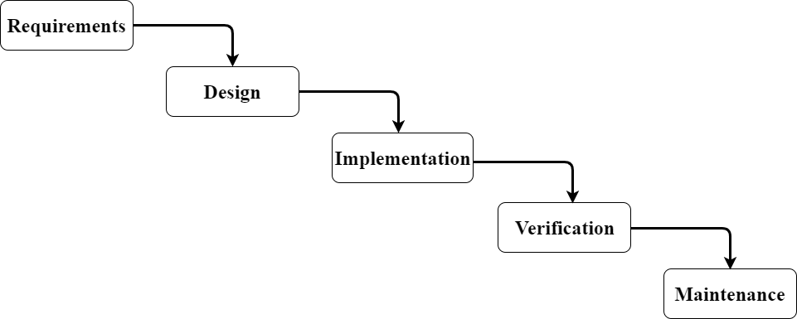

Spiral Model:

Bigger projects have big risks associated with them. Waterfall model due to its sequential nature is more prone to risk. Spiral Model is developed for projects where risks are high. All the phases that are in the waterfall model are also in the Spiral Model but with the addition of risk analysis. Each case involves risk identification and analysis. The other difference from Waterfall is its iterative nature. Which means that going back and forth among phases is allowed.

Advantages:

- Sensitive to risk
- Mistakes made in one phase can be corrected by going back to that phase

Disadvantages:

- Only usable for large scale and in house development

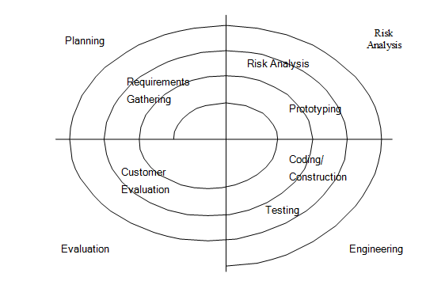

2.4 Chosen Methodology:

The adopted methodology in this project is VU process Model which is a combination of Waterfall Model and Spiral Model.

2.5 Reasons for choosing the Methodology:

The framework of fountain style we can find easy way to do our venture because fountain is a type of very simple style for growth objective. The stages in the fountain style involve Need, Design, Confirmation, Execution and Servicing. NO prototyping idea. Each and every stage after successful working goes to another stage. In this style one thing should be kept in mind that there is no Repetitive.
Basically iterative is used for better software growth objective. It leads us to make changes everywhere in the growth procedure. For that we have chosen the Manage Model.
Spiral Model provides us the Model feature which is available in this style. Each and every stage includes prototyping and style procedure.
In the water fall style the procedure goes from top to bottom like a flow of water. But any new changes cannot be integrated in the middle of the venture growth procedure. Whereas the spiral style is best suited for tasks associated with threats.

2.6 Work Plan:

It is similar to a process section; however differs inside that it describes future rather than past actions. A project plan outlines in explicit detail how a project will be conducted, who will work, when and in what order every part will be skillful.

2.7 Project Schedule

I will take part in the overall activities of the project from requirements gathering, planning, designing to the coding and testing of the project. I will report to my supervisor.

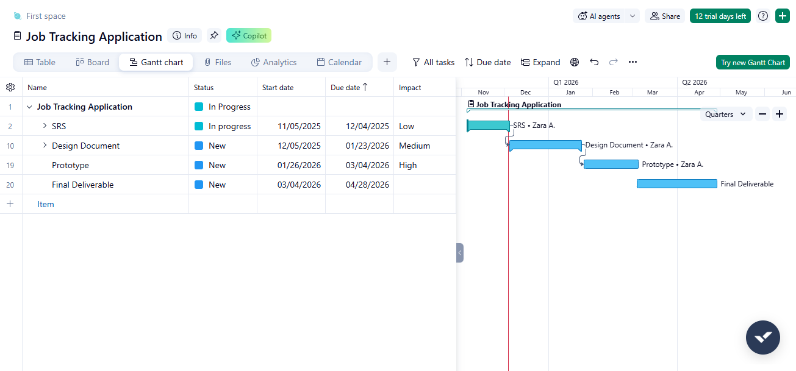

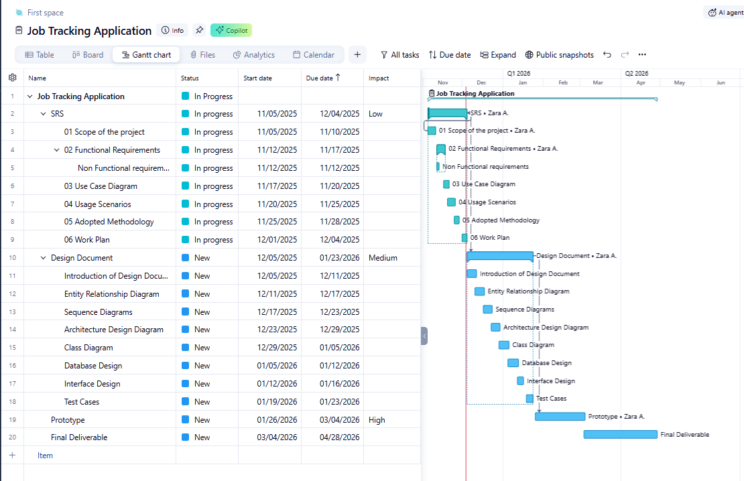

CHAPTER 3
Designing the Project

CHAPTER 3 - Designing the Project

3.1 Introduction:

Analysis and Design phase provides the appropriate mechanism for understanding and analyzing software needs , accessing feasibility , negotiating a reasonable solution , specifying the solution unambiguously , validating the specification and managing the requirements . This phase describes a pattern of interaction among objects; it shows the objects participating in the interaction by their links to each other. It is used by designer to define and clarify the roles of the objects in system. This phase is the source of information used to determining the object responsibilities.

3.2 Scope:

In this document I are going to provide high level overview, understanding and analyzing of our mobile application.

Following Diagrams, Designs and Test Cases, will help and provide guidelines to build database, business layer, presentation layer and testing process makes easy and feasible.

- Entity Relationship Diagram (ERD)
- Sequence Diagrams
- Architecture Design Diagram
- Class Diagram
- Database Design
- Interface Design and Test Cases

3.3 Entity Relationship Diagram (ERD):

ERD Diagram Follow these rules and regulation;
- One user can create many job applications.
- One job application belongs to a single user.
- One job application can have multiple documents.
- One document belongs to a single job application.
- One job application can have multiple reminders.
- One reminder belongs to a single job application
- One reminder can generate multiple notifications.
- One notification belongs to a single reminder.
- One user can receive many notifications.

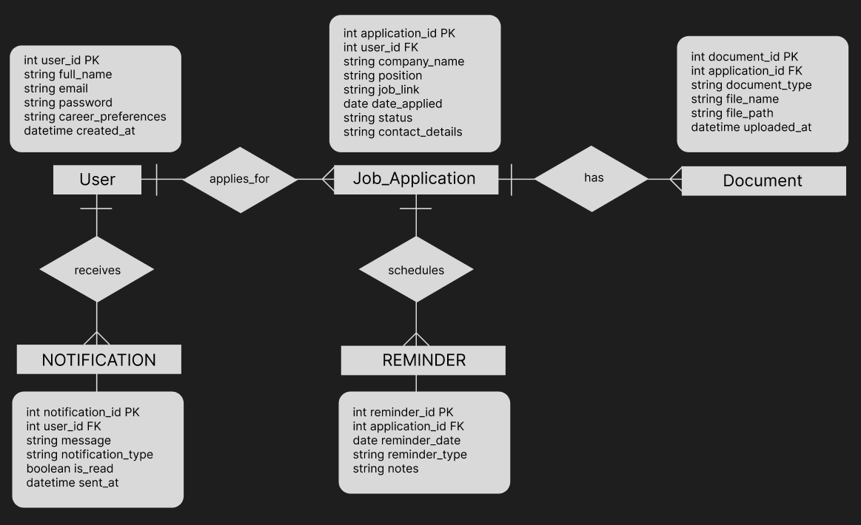

3.4 Sequence Diagrams

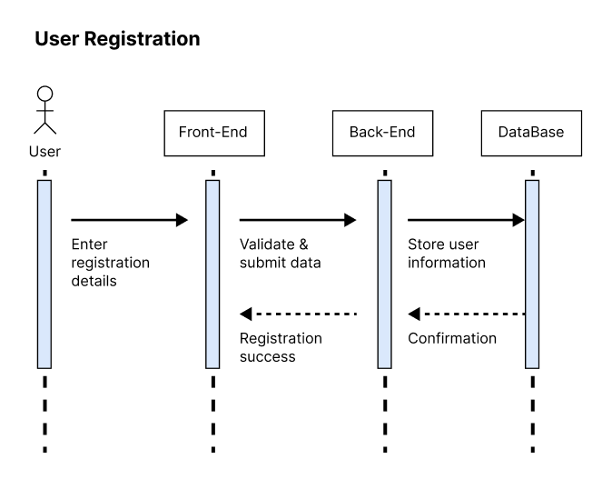
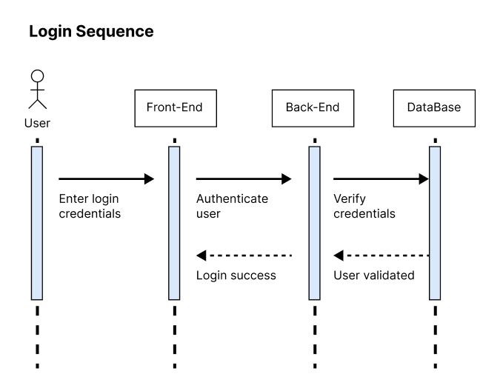
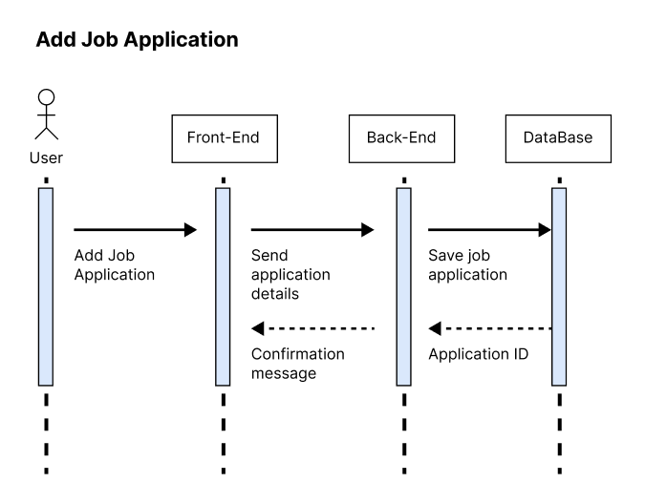
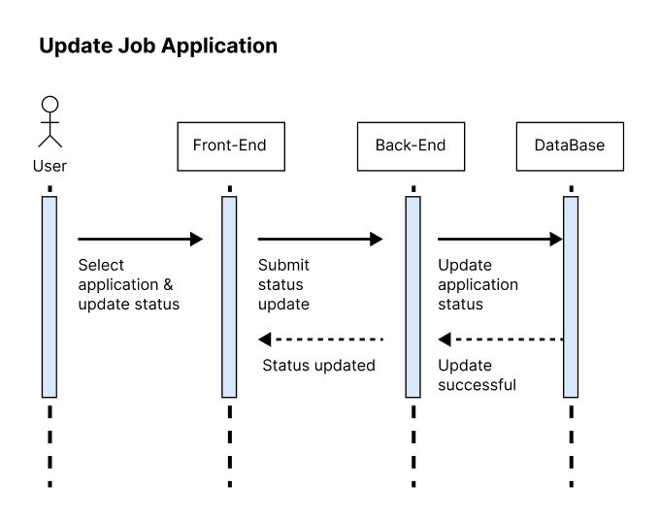
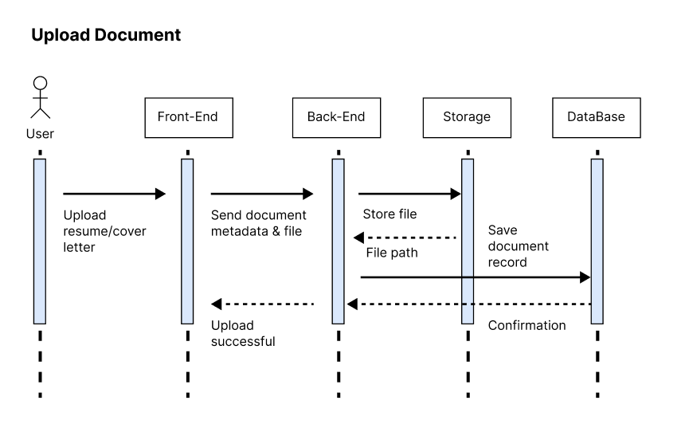
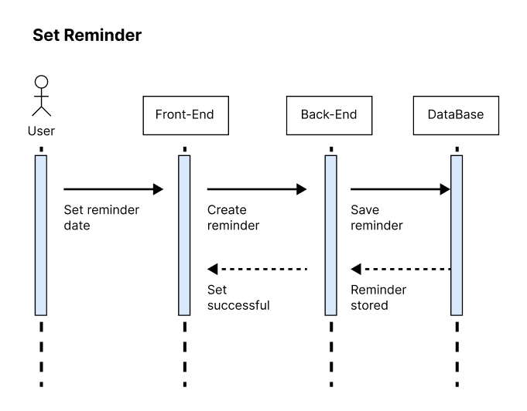
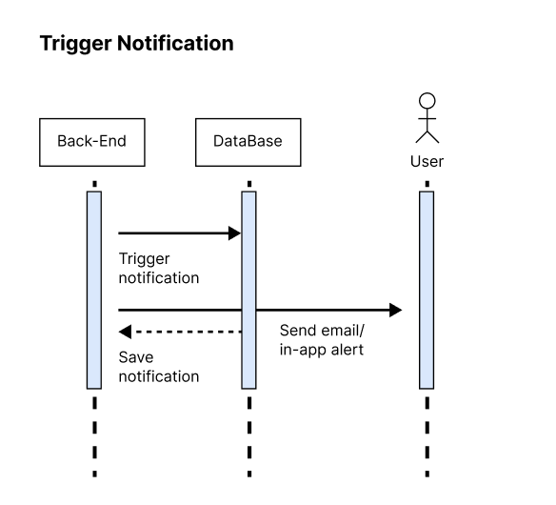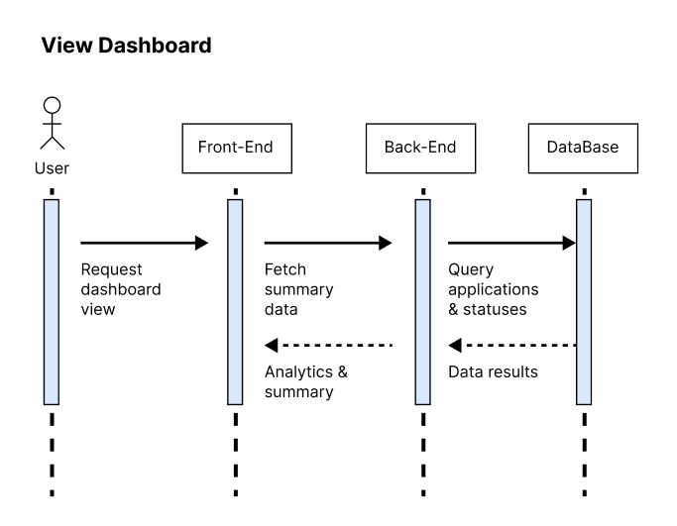

3.5 Class Diagram

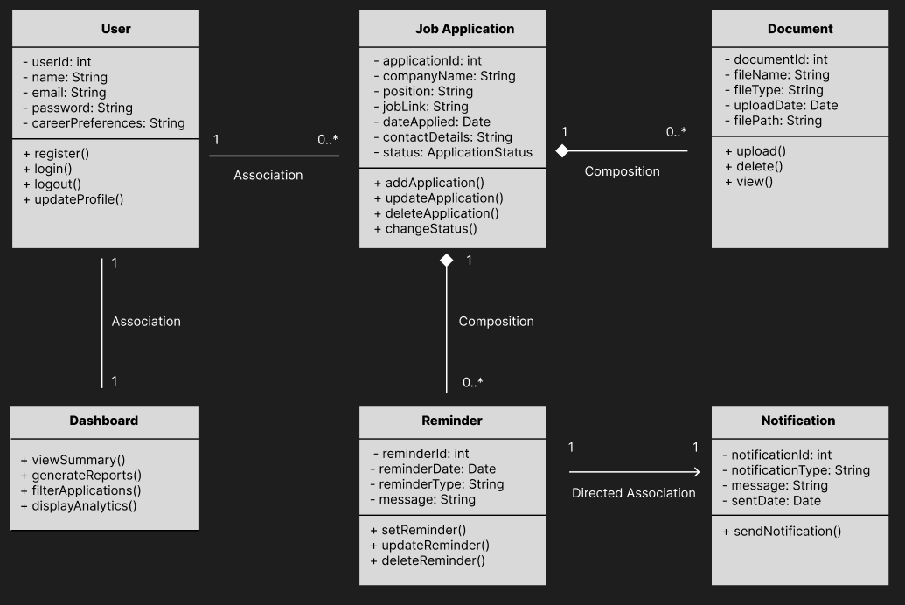

3.6 Database Design

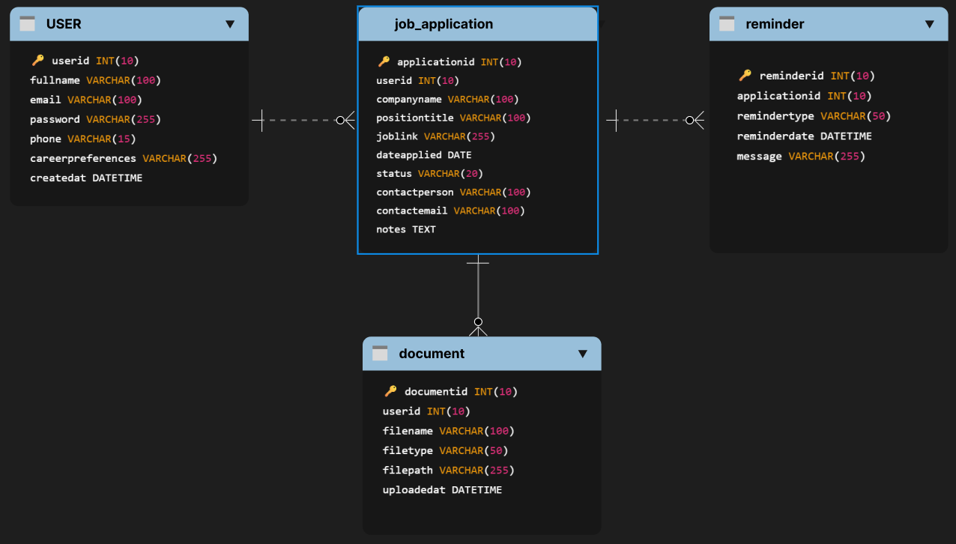

3.7 Interface Design

Lading Screen

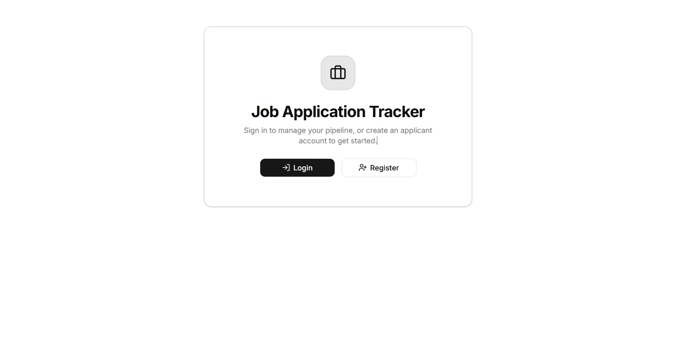

Login Screen

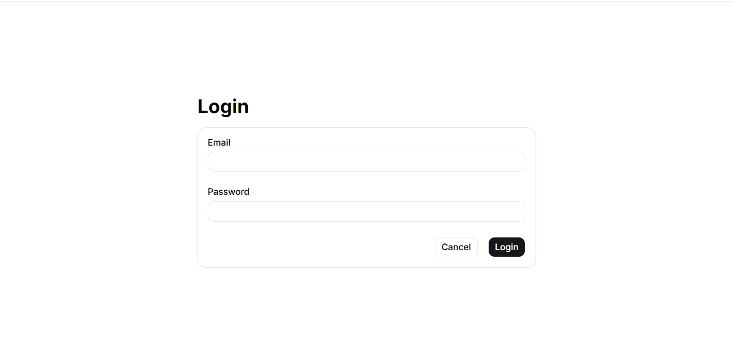

Register Screen

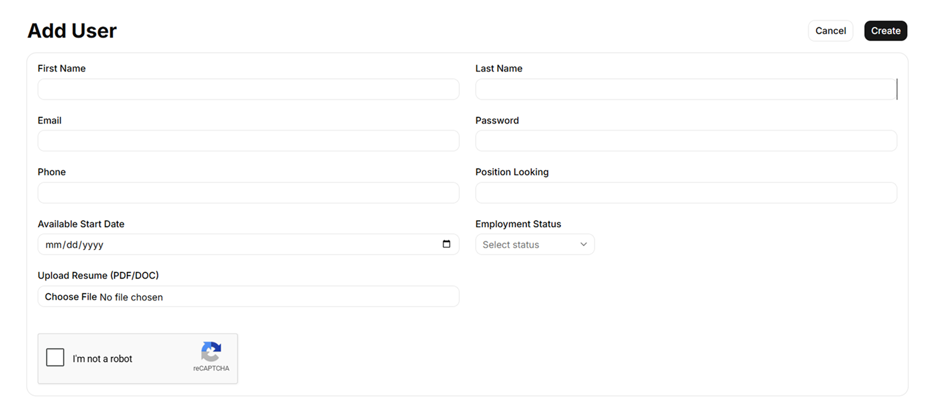

Dashboard

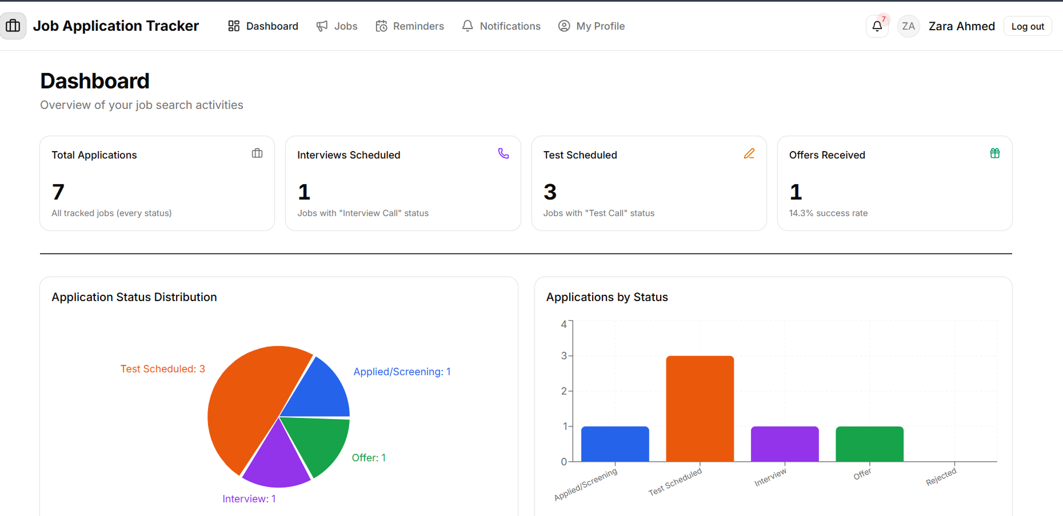

Job Application List Page

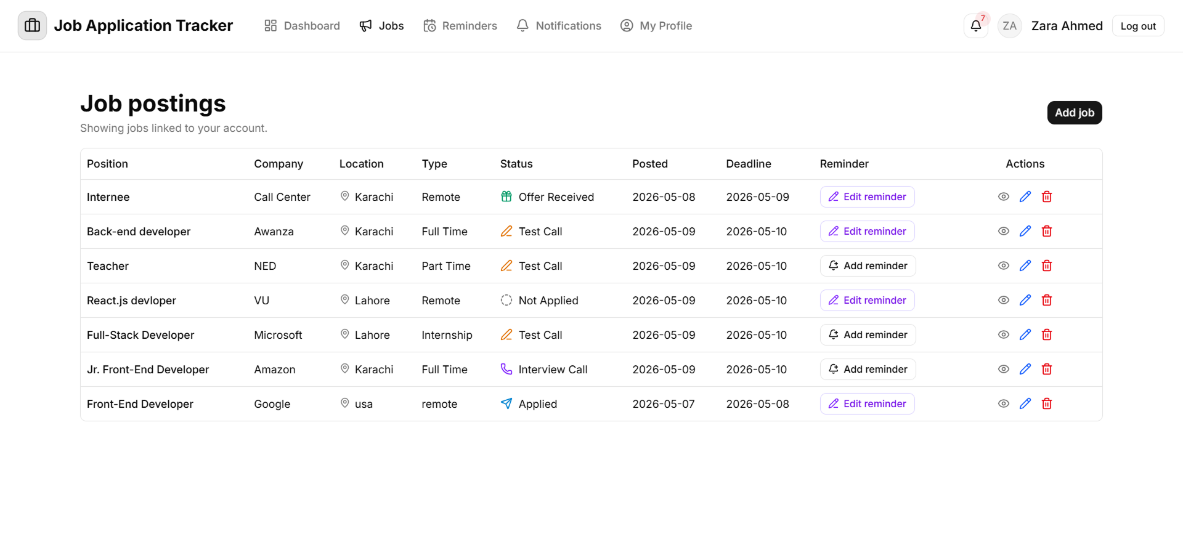

Add Job Application

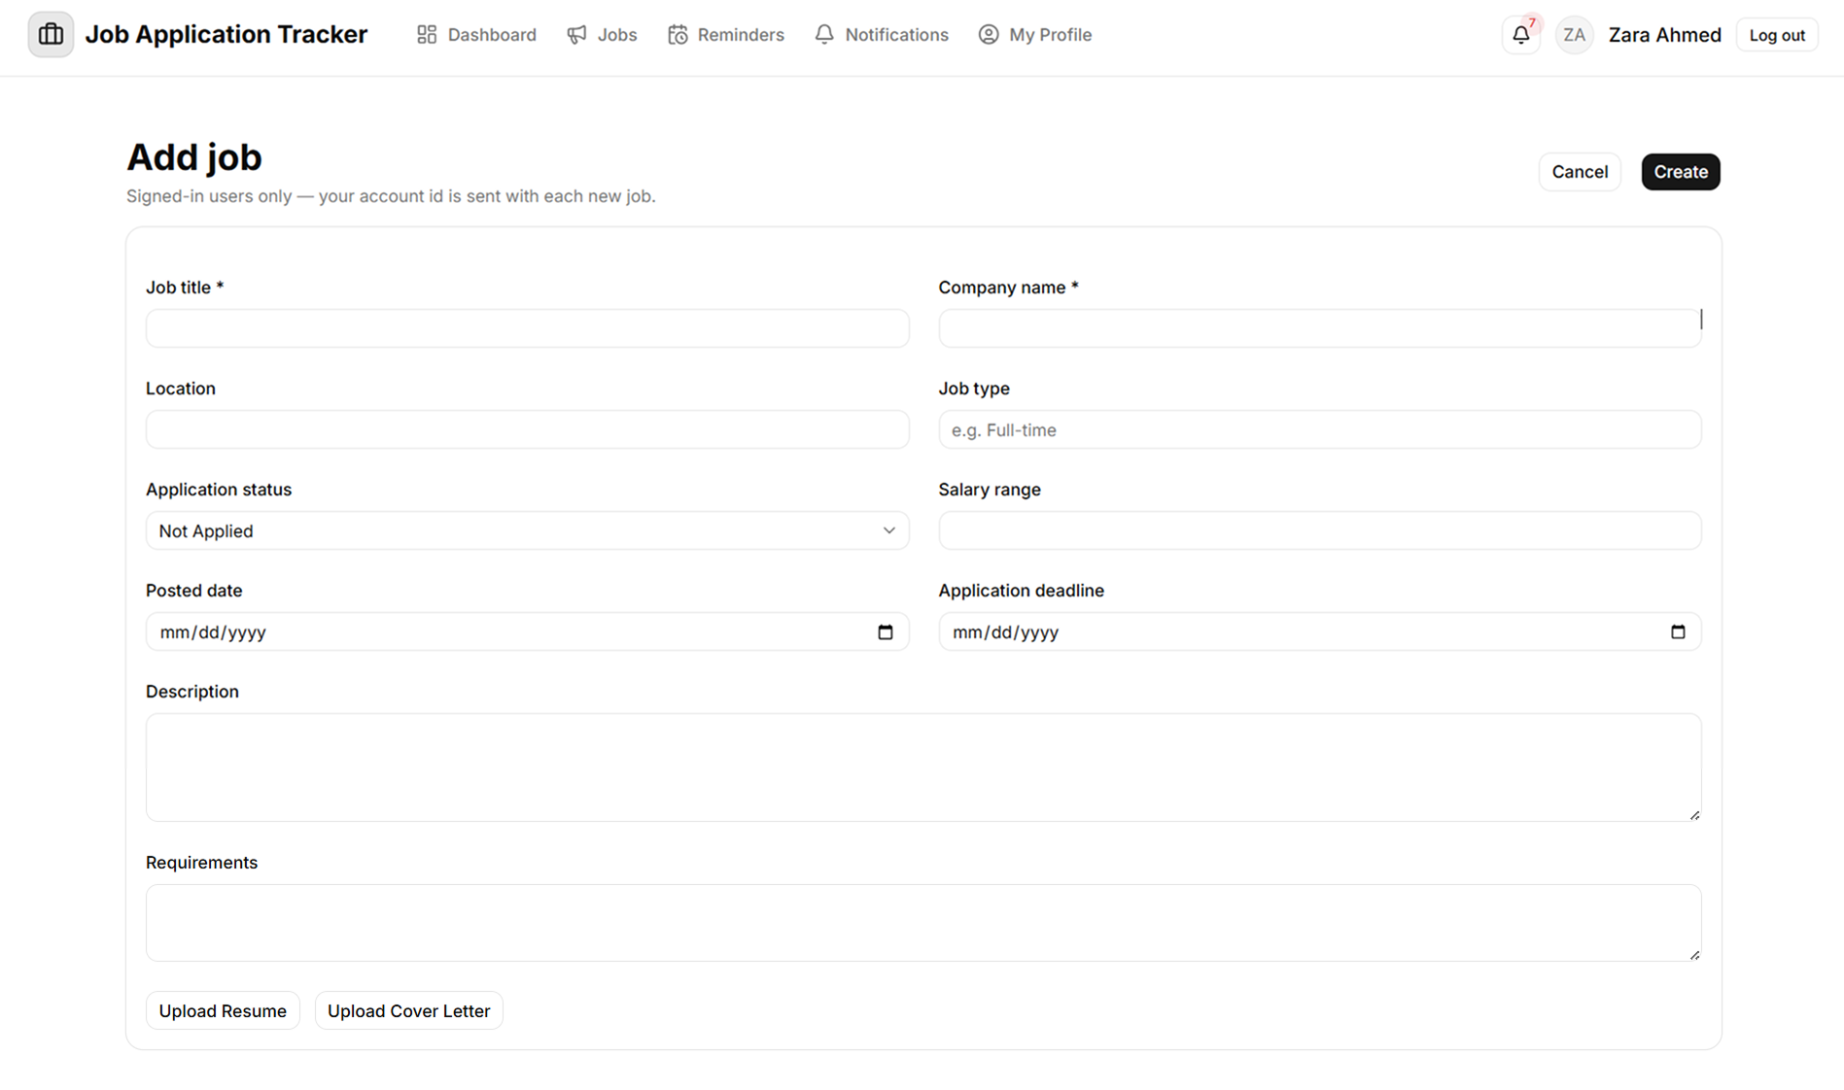

Application Detail

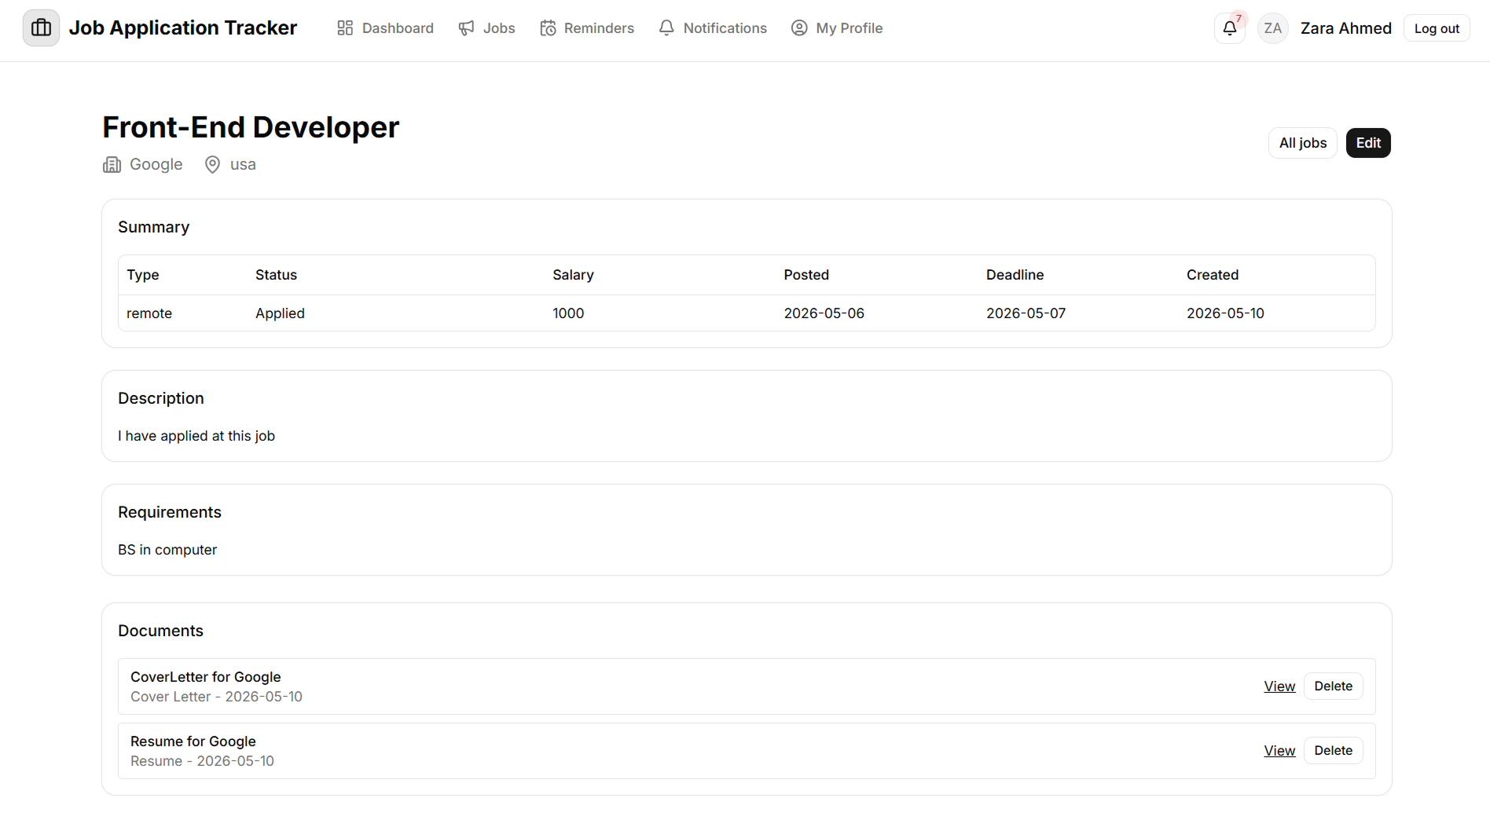

Edit Application

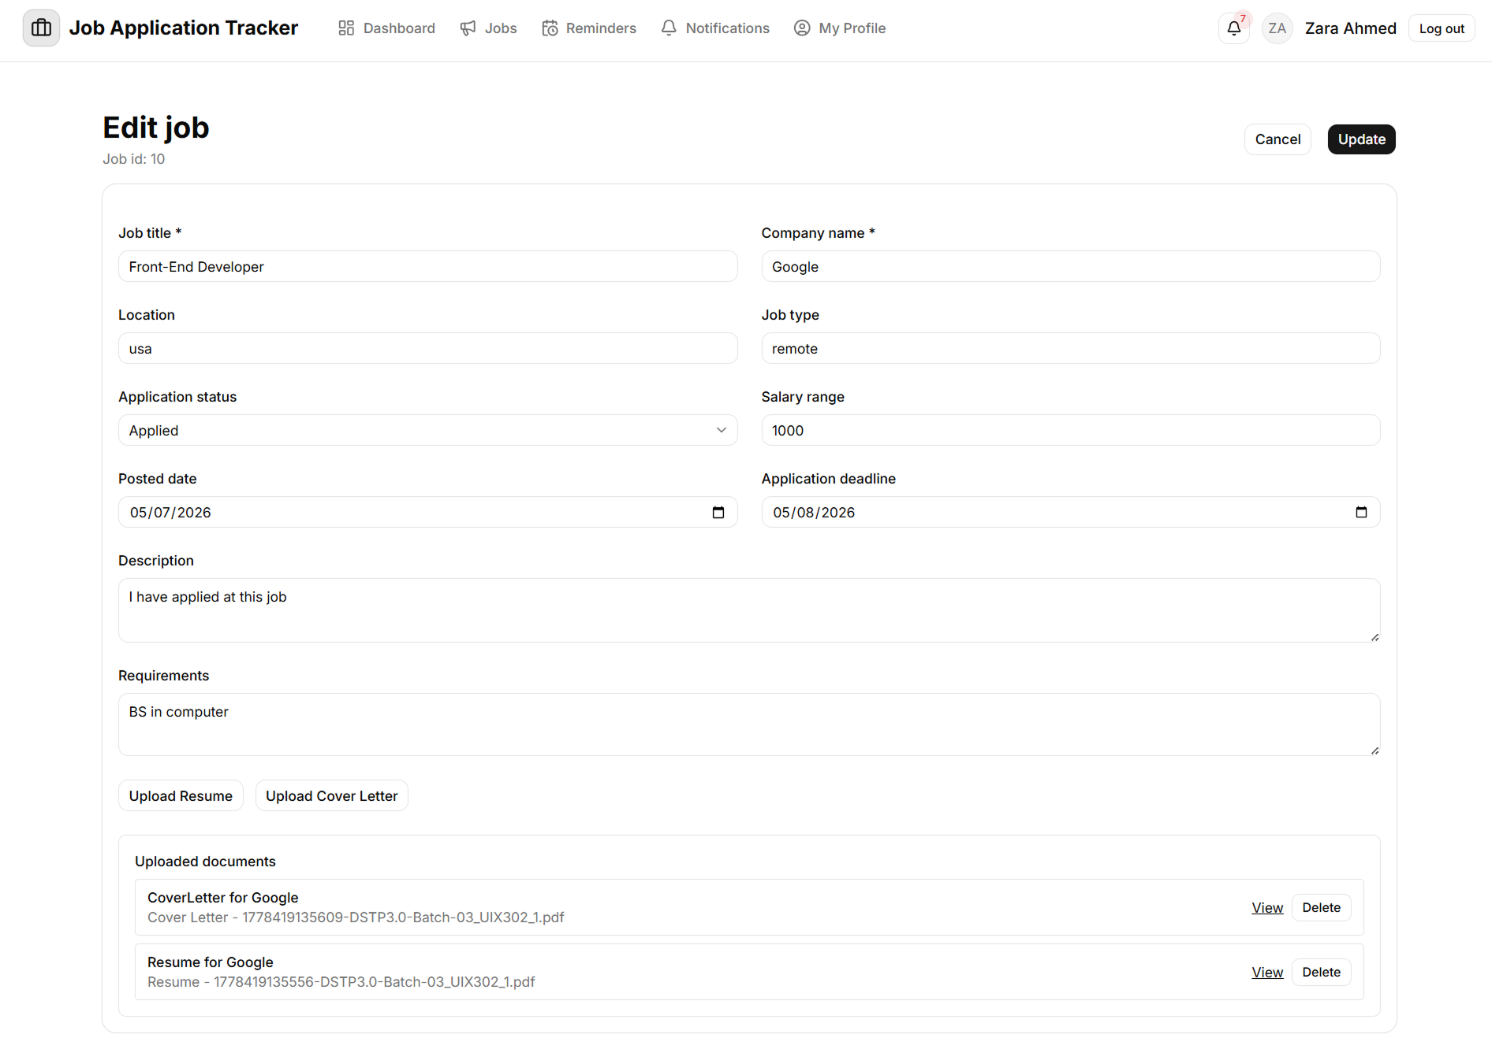

Add Reminder

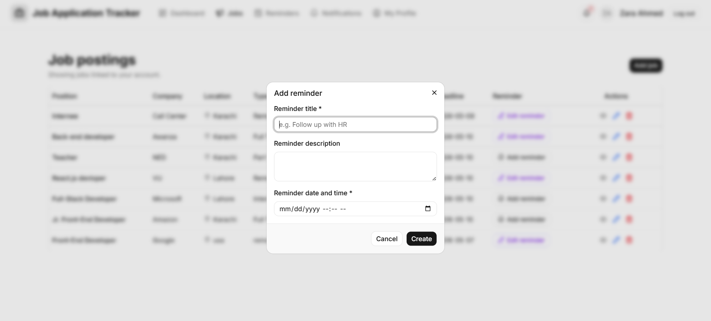

Edit Reminder

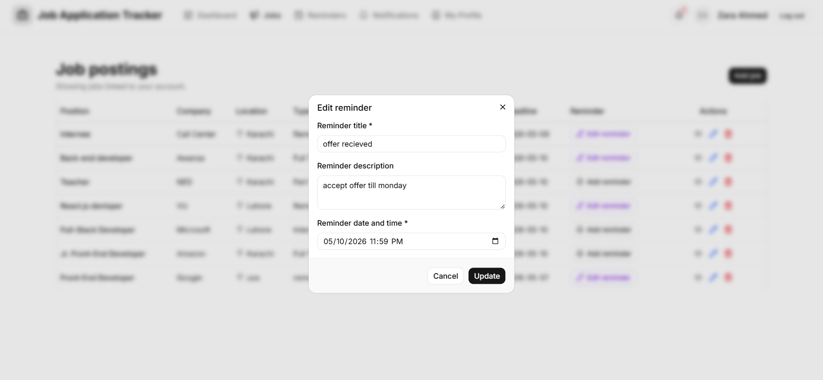

Reminder List page
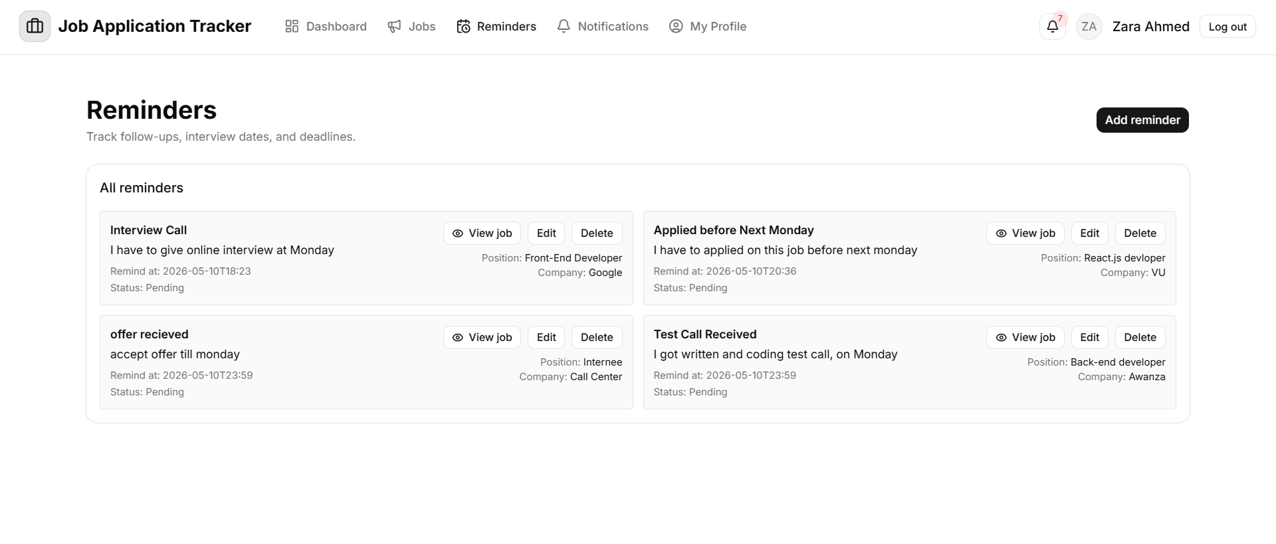

Notification List page

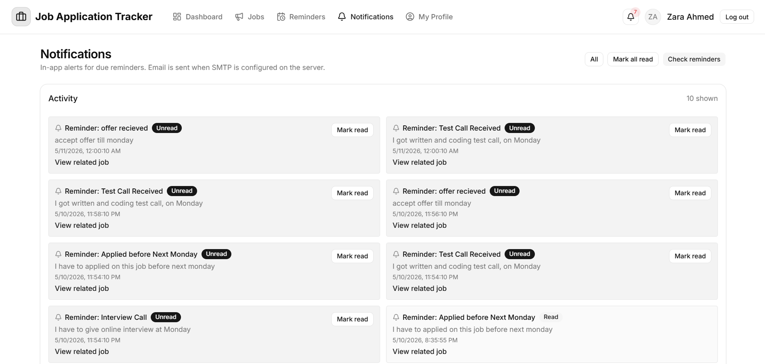

Profile page

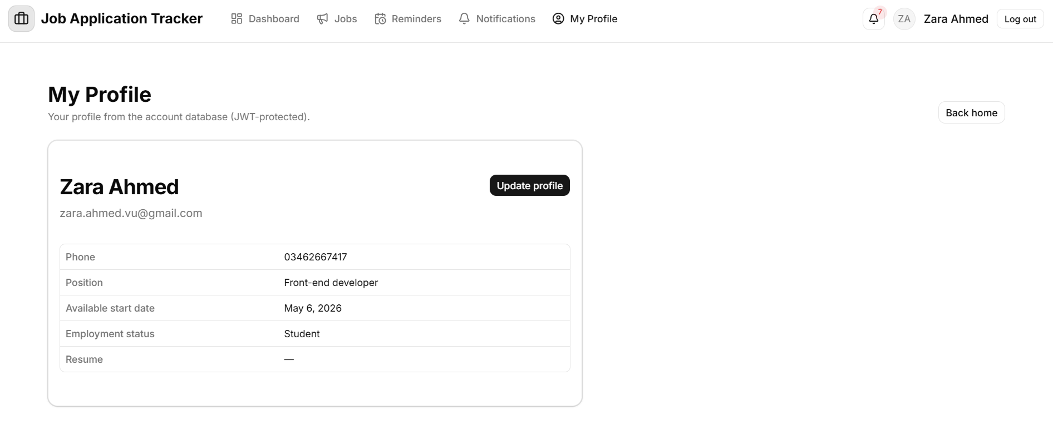

Edit Profile page

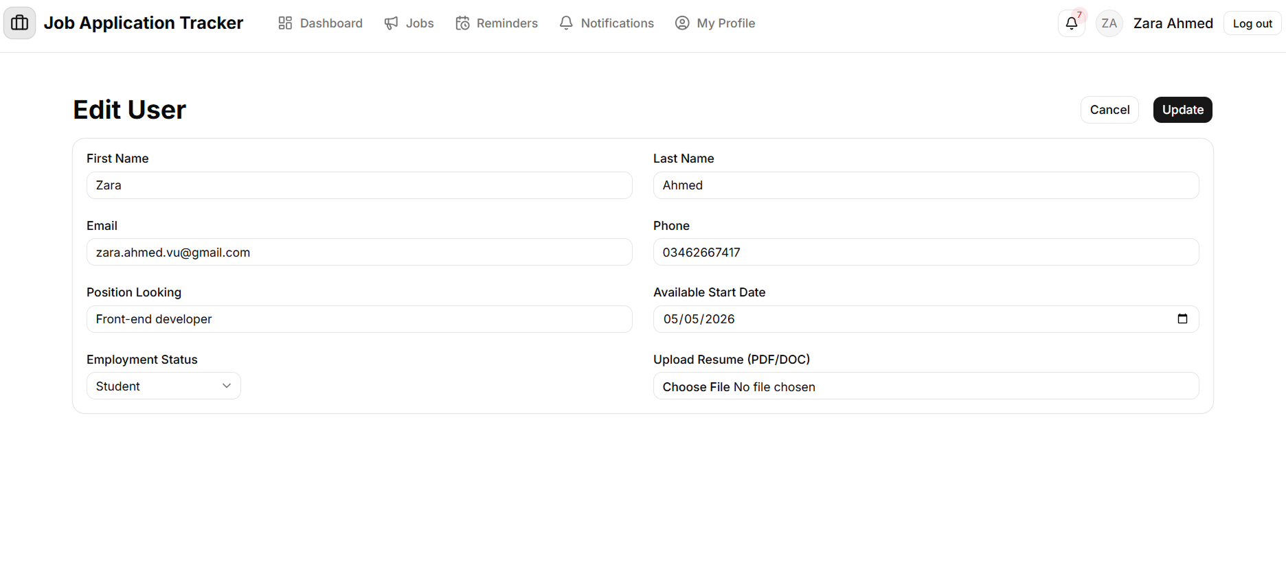

CHAPTER 4
Development

CHAPTER 4 - Development

4.1 Architecture Design Diagram

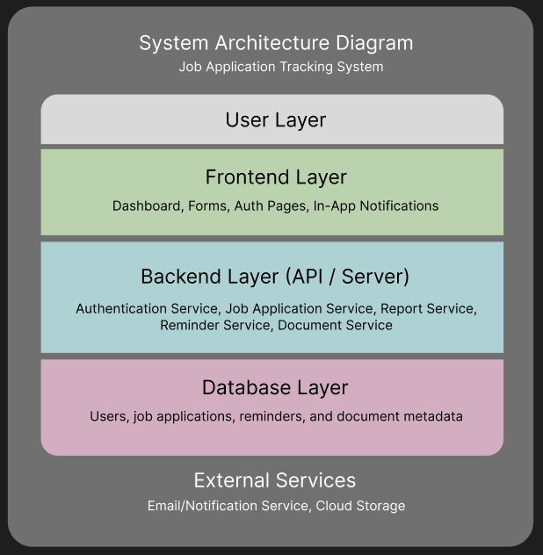

4.2 Test Cases

Test Case # 1

Test Case Title: User Registration.
Description: Verify that a new user can register successfully.

Preconditions | User is not registered.
Actions | - Open registration page  - Enter valid name, email, and password  - Click “Register”
Expected Results | User account is created and confirmation message is displayed.
Tested By: | Zara Ahmed
Result | Pass/Fail

Test Case # 2

Test Case Title: User Login.
Description: Verify registered user can log in.

Preconditions | User account exists.
Actions | - Enter valid email and password  - Click “Login”
Expected Results | User is redirected to dashboard.
Tested By: | Zara Ahmed
Result | Pass/Fail

Test Case # 3

Test Case Title: Invalid Login Attempt
Description: Validate error handling for incorrect credentials.

Preconditions | User is registered in the system.  User is on the login page.
Actions | - Enter incorrect email or password  - Click “Login”
Expected Results | Error message is displayed.
Tested By: | Zara Ahmed
Result | Pass/Fail
Test Case # 4

Test Case Title: Profile Management.
Description: Verify user can update profile information.

Preconditions | User is registered.  User is logged into the application.
Actions | - Navigate to profile page  - Edit basic details and career preferences  - Save changes
Expected Results | Profile updates are saved successfully.
Tested By: | Zara Ahmed
Result | Pass/Fail

Test Case # 5

Test Case Title: User Logout
Description: Verify user can log out securely.

Preconditions | User is logged into the application.
Actions | - Click “Logout”
Expected Results | User session ends and login page is displayed.
Tested By: | Zara Ahmed
Result | Pass/Fail

Test Case # 6

Test Case Title: Add New Job Application.
Description: Verify user can add a job application.

Preconditions | User is logged into the application.
Actions | - Click “Add Application”  - Enter company, position, job link, date applied, contact details  - Save application
Expected Results | Application is saved and displayed in the list.
Tested By: | Zara Ahmed
Result | Pass/Fail
Test Case # 7

Test Case Title: Update Job Application.
Description: Verify editing an existing job application.

Preconditions | User is logged in.  At least one job application exists.
Actions | - Select an existing application.  - Modify application details.  - Save changes.
Expected Results | Updated details are reflected correctly.
Tested By: | Zara Ahmed
Result | Pass/Fail

Test Case # 8
Test Case Title: Delete Job Application
Description: Verify application deletion.

Preconditions | User is logged into the application.
Actions | - Select the application.  - Click “Delete”.  - Confirm deletion.
Expected Results | Application is removed from the list.
Tested By: | Zara Ahmed
Result | Pass/Fail

Test Case # 9
Test Case Title: Track Application Status
Description: Verify status tracking functionality.

Preconditions | User is logged in.  A job application exists.
Actions | - Select an application.  - Change status (Applied → Interview → Offer, etc.).
Expected Results | Application status updates correctly.
Tested By: | Zara Ahmed
Result | Pass/Fail

Test Case # 10
Test Case Title: Attach Documents to Application
Description: Verify document upload for an application.

Preconditions | User is logged in.  A job application exists.  Valid document files are available for upload.
Actions | - Open application details.  - Upload resume or cover letter.
Expected Results | Documents are attached successfully to the application.
Tested By: | Zara Ahmed
Result | Pass/Fail

Test Case # 11
Test Case Title: View Application Summary
Description: Verify dashboard summary view.

Preconditions | User is logged in.  At least one job application exists.
Actions | Open dashboard.
Expected Results | Counts of active, pending, and completed applications are displayed.
Tested By: | Zara Ahmed
Result | Pass/Fail

Test Case # 12
Test Case Title: Set Reminder
Description: Verify reminder creation.

Preconditions | User is logged in.  A job application exists.
Actions | - Select an application.  - Set reminder for interview or follow-up.
Expected Results | Reminder is saved successfully.
Tested By: | Zara Ahmed
Result | Pass/Fail

Test Case # 13
Test Case Title: Edit Reminder
Description: Verify reminder modification.

Preconditions | User is logged in.  At least one reminder exists.
Actions | - Edit existing reminder.
Expected Results | Updated reminder is saved successfully.
Tested By: | Zara Ahmed
Result | Pass/Fail

4.3 Development Tools & Technologies

- Tool
Microsoft VS Code and Cursor

- Database
MySql and Workbench

- Development language
JavaScript

- Server
Node.JS and Express

- Front-End
React.Js and Shadcn+Tailwind

Thanks You!
Zara Ahmed
BC220409531

